Dis-Asia-Japan-Haniwa Woman Wearing Coat with Wave Pattern-Kofun Period-250 to 538 AD-CE

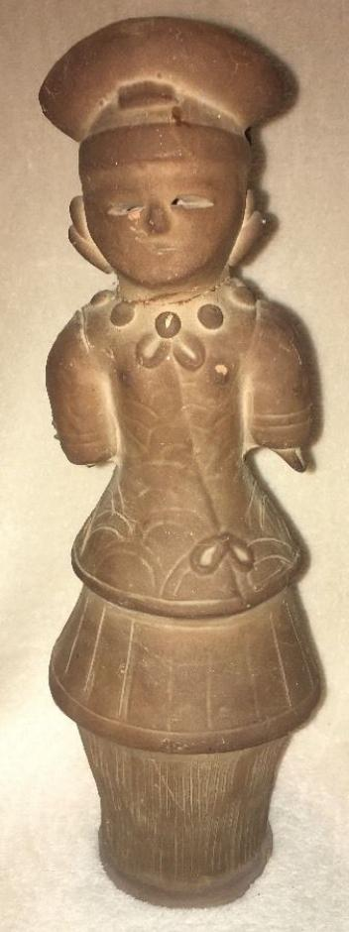 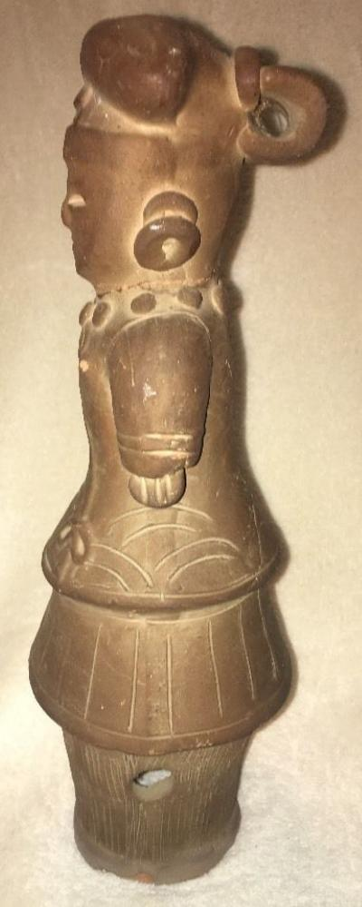 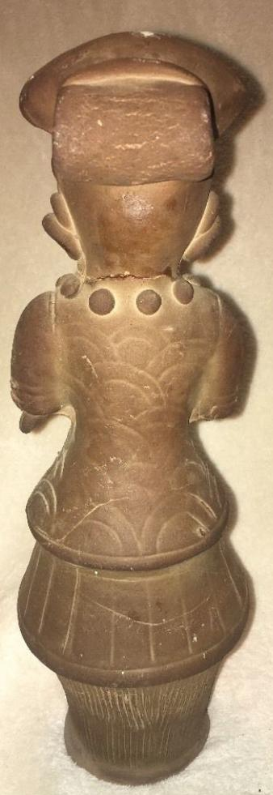 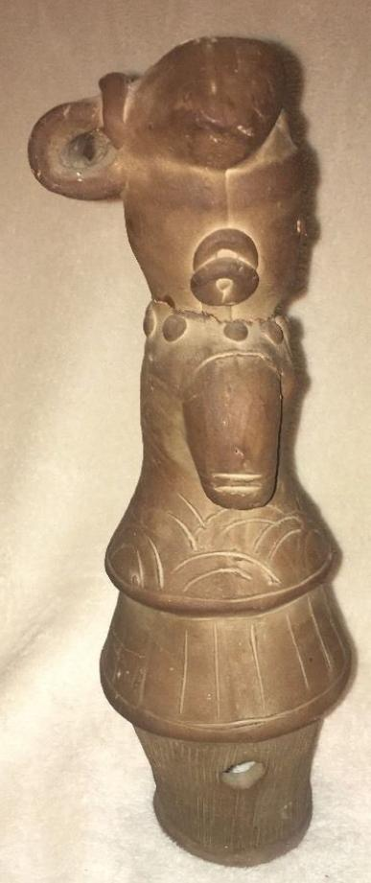 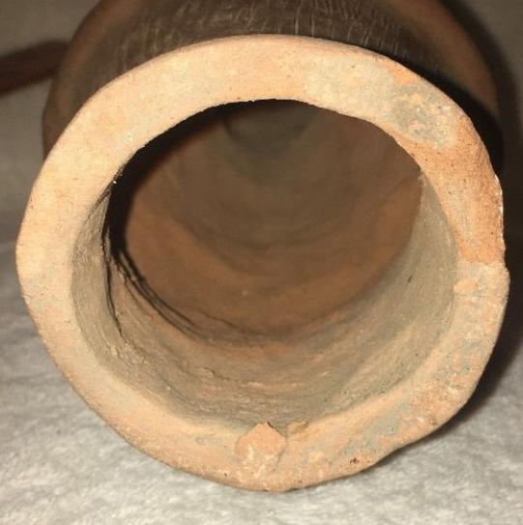 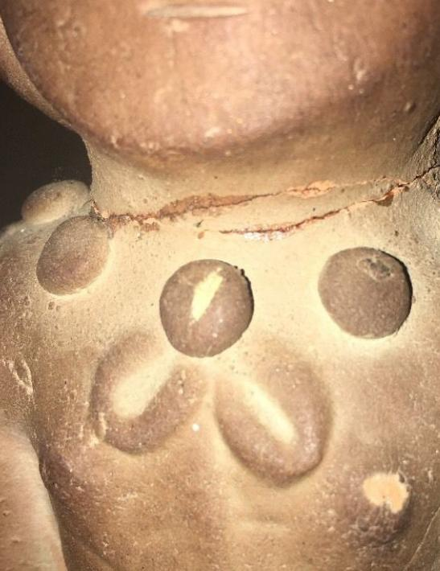 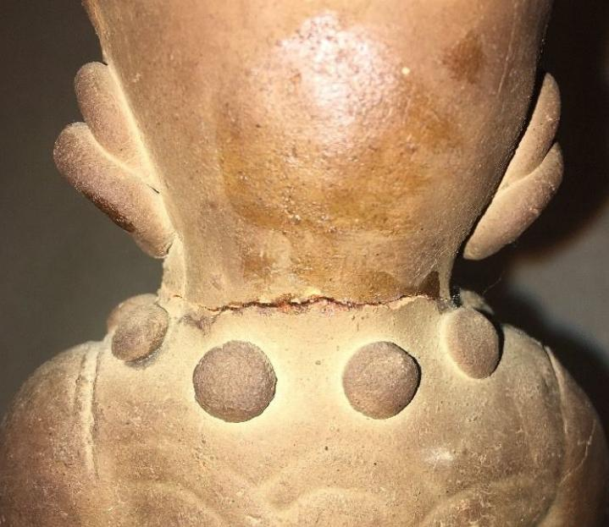

Formal Label: Japanese Haniwa Woman Wearing Coat with Wave Pattern, Kofun Period-250 to 538 AD-CE

Accession Number: NB 1667.A1

Date or Time Horizon: 250 to 538 AD-CE

Geographical Area: Japan

Cultural Affiliation: Kofun Period. Early copy, ca. 1900, of Woman Wearing Coat with Wave Pattern from Hachisu, Isezaki-shi, Gumma Prefecture Prefecture, Kanto Region (Miki 1961: plate 6).

Medium: Terracotta

Dimensions: 12 in

Weight:

Provenance: U.S. Naval Captain, Occupied Japan, 1947.

**Condition:** Mended cracks, missing one hand.

**Discussion**: This female figure is adorned with large ear-jewels as well as earrings , necklace and jeweled bracelets. The upper garment has a wave pattern common also in much later Japanese art, while the skirt-like lower garment is decorated with vertical stripes. With her drawn in waist she presents a figure with an easy flare of the upper and lower garments.

**References:** Miki, Fumio. 1961. Haniwa : the clay sculpture of protohistoric Japan / English adaptation by Roy Andrew Miller. Rutland, Vt./ Tokyo, Japan: C.E. Tuttle, [1961]